Aloud or Allowed?

Aloud
Aloud simply means: Out loud.
E.g. He read his work aloud.

Allowed
This means something is permitted.
You are allowed to do it.
E.g. You are allowed to drink water in class.

Tips:
- If the word ‘loud’ is within the word, it refers to sound.
Speaking aloud.

- If the word ‘allow’ is within the word, it refers to permission.
We were not allowed (given permission) to play outside.

- Ensure you proof read your sentences carefully!

Complete the following sentences with allowed or aloud. (Tip: Out loud or permitted?)

- No mobile phones ________ in the exam hall.

- The teacher _______ the students to work in pairs.

- We try to speak clearly when reading _____.

- The best way to learn your lines is to read them _____.

- She _______ her best friend to borrow her new jacket.

- Her friend didn’t want to ask _____, so she sent a text instead!

- Children are not _____ in the shop without an adult.

- Reading _____ to younger siblings will improve your confidence.

- The cinema ______ us to bring our own sweets.

- Students are not _____ to wear hoodies in class.

Answers: 1. allowed 2. allowed 3.aloud 4.aloud 5. allowed 6. aloud 7. allowed
8. Aloud 9. allowed 10. Allowed.

Extension Task below:

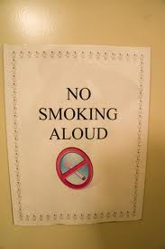
Identify the mistakes in the following signs.
Explain each mistake and help the person to correct their sign.

