Accept vs. Except

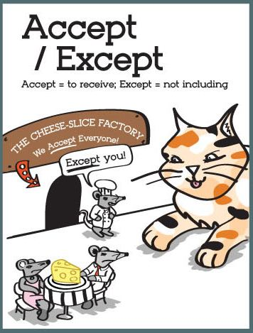
Accept is a verb
It means ‘to agree with something’ or ‘to receive something’.
E.g.: The shop will only accept the returned items within 30 days.

Except
This means ‘not including’.
E.g. All prime numbers, except 2 and 5, end in 1, 3, 7 or 9.

Complete the following sentences with ‘accept’ or ‘except’.
- Please _____ these flowers as a token of apology.

- All the girls played netball ______ Mary.

- The whole class remembered choir _____ Paul.

- It will cure anything _____ laziness!

- His mum could not ______ the job as it was too far away.

- He _______ed the award with great pride.

- I can’t ______ your invitation. We will be on holiday.

- I have nothing to declare _____ my genius. (Oscar Wilde)

- Move all the furniture, _______ the piano.

10. I _______ your apology, thank you.
Answers: 1. Accept 2. Except 3.except 4. Except 5. Accep t 6. Accepted 7. Accept 8. Except 9. Except 10 accept
Extension Task:
Explain what’s wrong with the following images and recommend a way for each person to correct their mistake.
