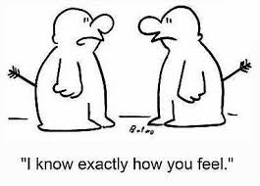
Empathise or Emphasise?

Emphasise (“Empf-fa-size”)
To add emphasis to something. If you emphasise something you make it stand out.

Synonyms for Emphasise: Highlight, stress, accentuate.

You might emphasise a key word by changing its colour.
You might emphasise your favourite facial feature by having your hair cut in a certain style.
“I like your hair. It emphasises your smile.”

Empathise (“Em-pa-thighs”)
To have empathy. To relate to or understand the feelings of others.
The ending is similar to sympathise. Empathising means you have been through a similar ordeal / can put yourself ‘in their shoes’. Having a deep understanding means you are empathising.
Year 12 empathise with Year 11 as they remember GCSE pressure.
Task 1
Read this aloud:

The teacher emphasised the importance of empathising with others.

Task 2
Right-click on emphasised then empathising. Replace with synonyms of your choice to help you remember the difference.

Task 3
Write your own sentences with emphasise or empathise.

Remember…
- Emphasise: The ‘ph’ sound can be emphasised when said aloud. The ending sounds like ‘size’ – something that could emphasise your point.

- Empathise: The word ‘path’ is within it. If you have followed the same path as somebody you would empathise with them.

Extension: Share your own memory techniques with the class. Could you relate the ph to emphasis in Science?

