‘Less’ or ‘Fewer’?

Using the word ‘less’ in place of ‘fewer’ is a common mistake.

Less means ‘not as much’. It should be used when talking about something that is not easily counted or measured.
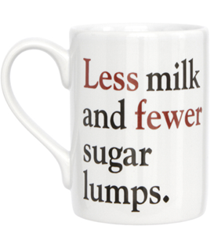
“I would like less milk in my coffee.”
We can’t easily measure the milk.
“Less chat, more work!”
It’s difficult to measure how much somebody talks.
“I drink less water when I’m busy.”
The water isn’t countable (although the bottles are - we could say fewer bottles of water).

Fewer means ‘not as many’. It should be used for items that can easily be counted one-by-one.
Fewer students attended Football due to the weather.
We can easily count the students.
There are fewer detentions given on Fridays.
We can easily count the detentions.
There are fewer cars in the car park in summer.
We can easily count the cars in summer and winter.

Exception to the Rule:
For numbers with time, money or distance, you should use less, not fewer.
For example: There are less than five minutes remaining.
Summary
Easily countable = Fewer. There were fewer apples in the canteen today.
Not easy to count / vague = Less. There was less rain last night.
Time, distance or specific amounts of money = Less. Year 11 have less than three days left.

Complete the following sentences with less or fewer:
Tip: Is it easily counted?
- I’ve been eating _____ chocolate bars since the Health Assembly.
- There are _____ rules in that school.
- He takes _____ care over his appearance on Saturdays.
- You get _____ lives on Level 5 of this game.
- There will be _____ students once Year 11 leave.
- It is illegal to earn _____ than £6.31 per hour.
- John had _____ mistakes in this week’s test.
- 10 items or ___ at this till.*
- We have Sports Day in _____ than ten weeks.
- There is ____ cold air in that classroom now.
Answers
1. Fewer 2. Fewer 3. Less 4.Fewer 5. Fewer 6. Less (specific amount of money) 7. Fewer 8. Fewer* 9. Less (refers to time) 10. Less.
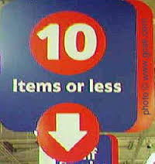
*Number 8 was controversial. Tesco displayed a sign that was incorrect. It should read ‘10 Items or Fewer’ as the items are countable.
It has now been taken down thanks to the ‘Plain English Society’!
Extension: Create your own ‘less’ or fewer’ sentences, based on your hobby.

