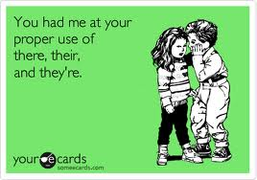
They’re
Their
There

They’re: A contraction of they are E.g. They’re good friends. The confusion probably relates to the fact that people are unsure about using apostrophes. When you write they're, ask yourself whether you can substitute they are. If not, you have made a mistake.

Their: A possessive pronouns similar to her and hers. The fact that heir (referring to a person who inherits something) is hidden in the words their might help you remember that they own something. E.g. I like their car.

There: The most commonly used. It can be used to refer to a place.
E.g. Shall I put it here or there? / There are only two tickets left.

PRACTICE EXERCISE
Choose the appropriate form: they’re, their, there.

1. _______ dog is very loud.
2. _______ once was a bird called a Dodo.
3. My aunt and uncle are arriving tomorrow. ___________ driving down from Scotland.
4. Many years ago __________ were no cars, so people used to travel by horse and carriage.
5. My neighbours have bought another car. ________ new one is red.
6. Surprisingly, both of __________ cars are 4WD.
7. If you look over ____________ you will see the beautiful sunset.
8. Have you seen where __________ building that new road?
9. I think __________ address is 52 Newlands Road.
10. Do you know what ____________ phone number is?

Answers: 1. Their, 2. There, 3. They’re, 4. there, 5. Their, 6. their, 7. there, 8. they’re, 9. their, 10. their.

